5.119: The analysis is the same as for Problem 5.95; in the case of the cone, the speed is related to the period by 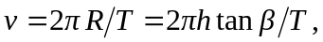 or 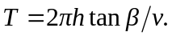 The maximum and minimum speeds are the same as those found in Problem 5.95,
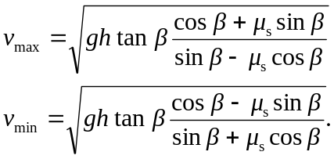
The minimum and maximum values of the period T are then
